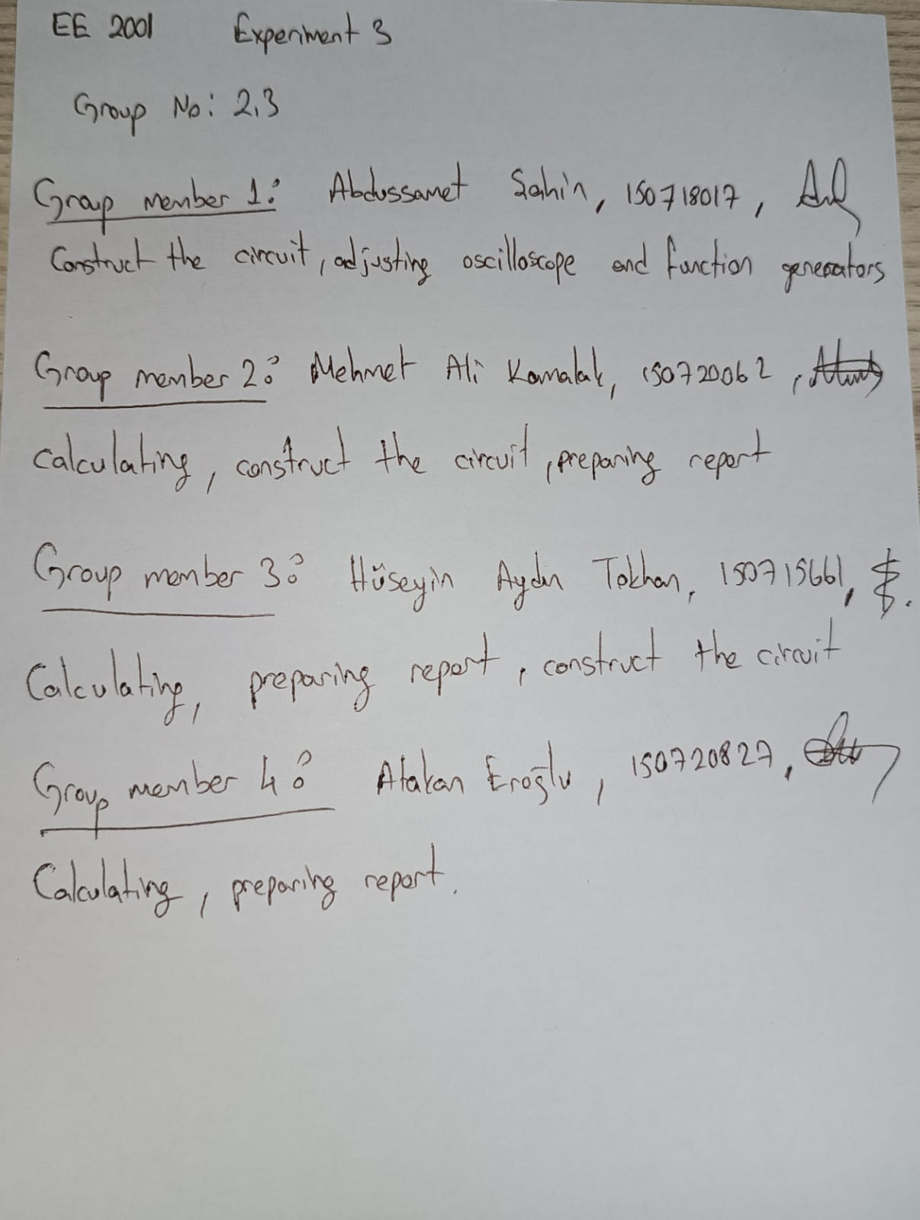

Q1) TO DO PHYSICALLY AT THE LAB ( Use: R = 3.3 kΩ, C = 22nF) Build a first order RC
circuit as below, adjust voltage square wave with peak value of 5 V at 1 kHz, observe and
record input and output one on the other using oscilloscope.
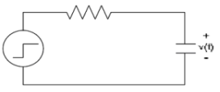

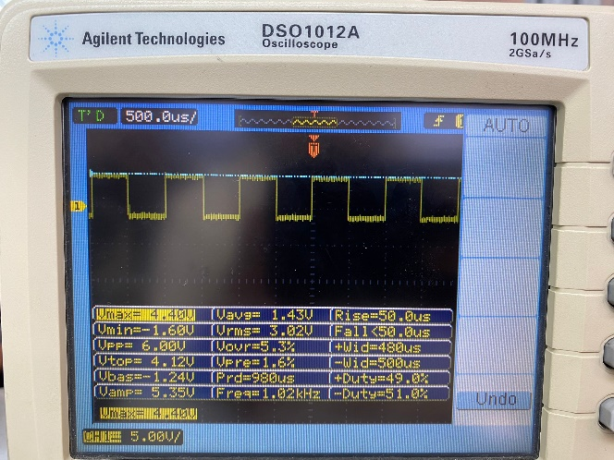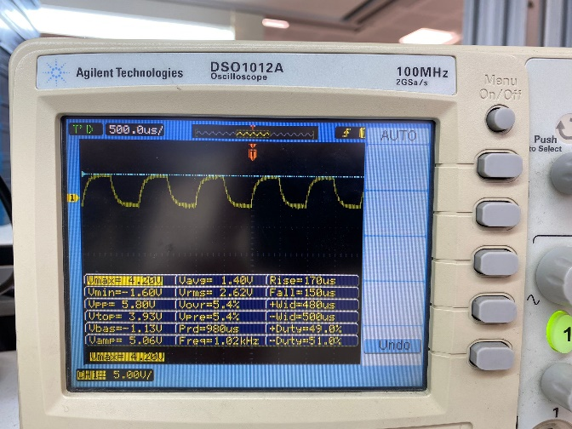
Figure 1: input Figure 2: output(R=3.3k)

Q2)
The time constant (τ) of the circuit was initially calculated using the formula τ=RC, where R is the resistance and C is the capacitance. In our case, τ was determined as
τ=(3.3kΩ)(22nF)=72.6µs
Alternatively, measuring the time to peak voltage yielded an approximate value of 42µs for τ. The discrepancy between the two values may be due to variations in circuit components or measurement inaccuracies, such as the oscilloscope reading 4.40V and 0.89kHz instead of the intended values

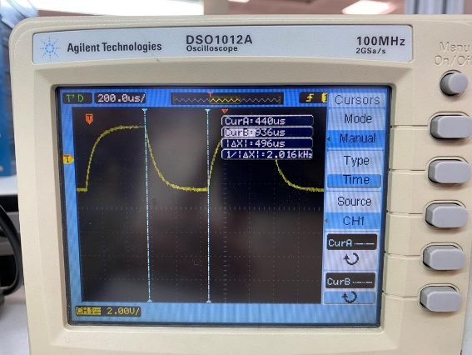
Figure 3 :time constant

Q3)

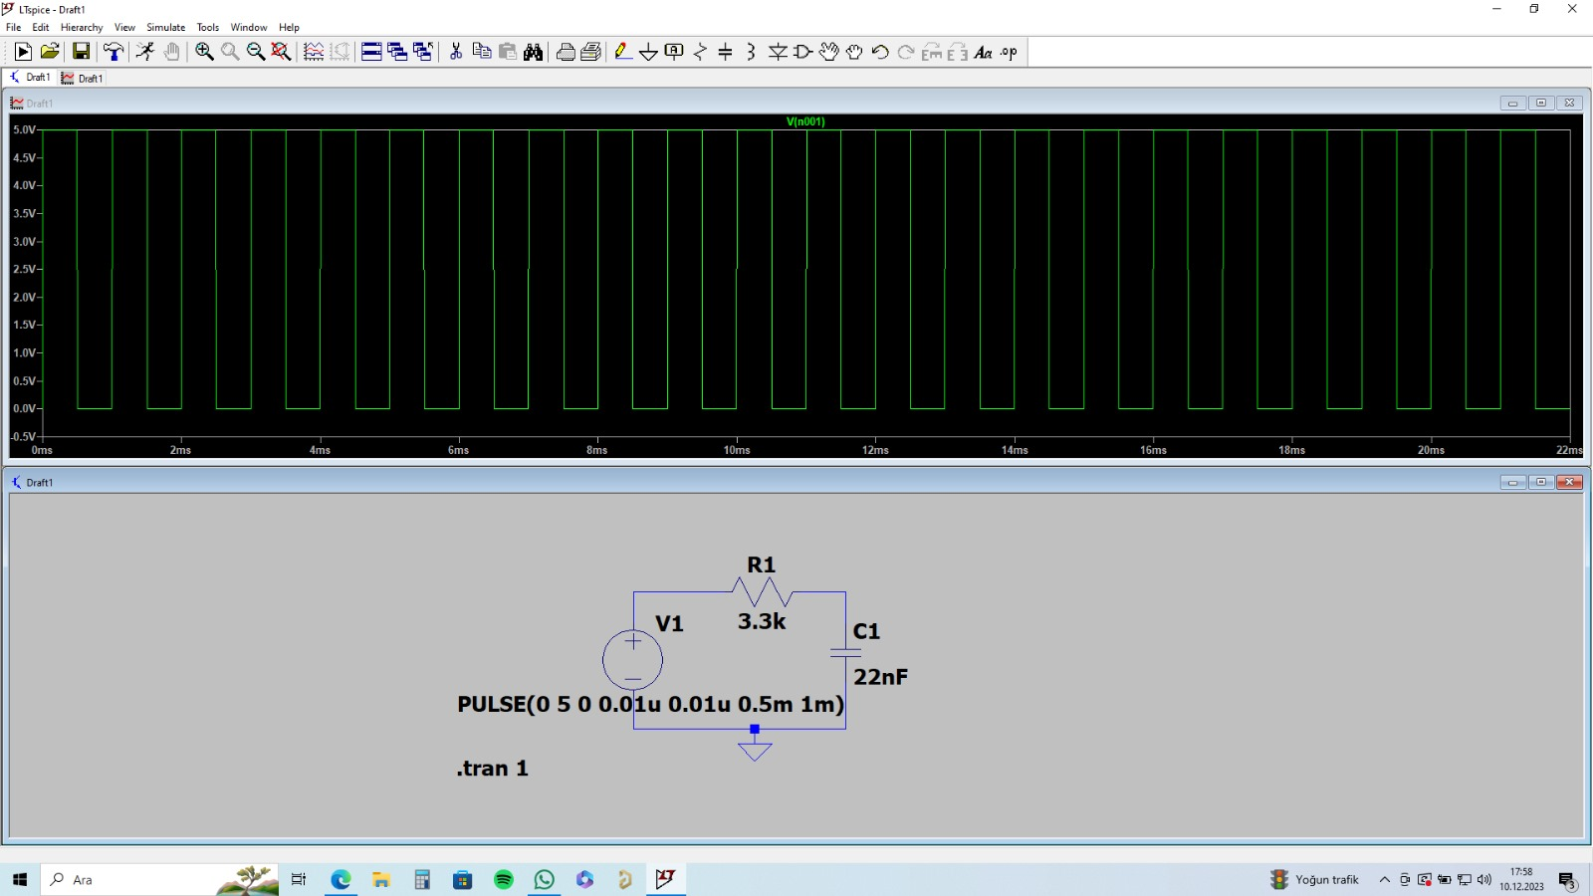
Fig. 1: The Circuit 1

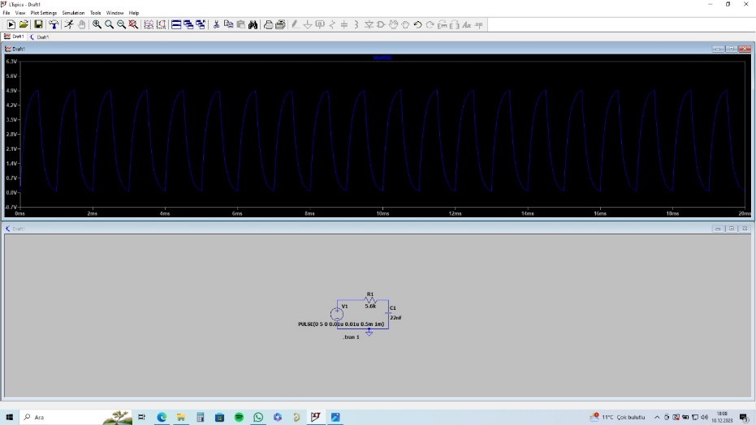
Fig. 2: The Circuit 2

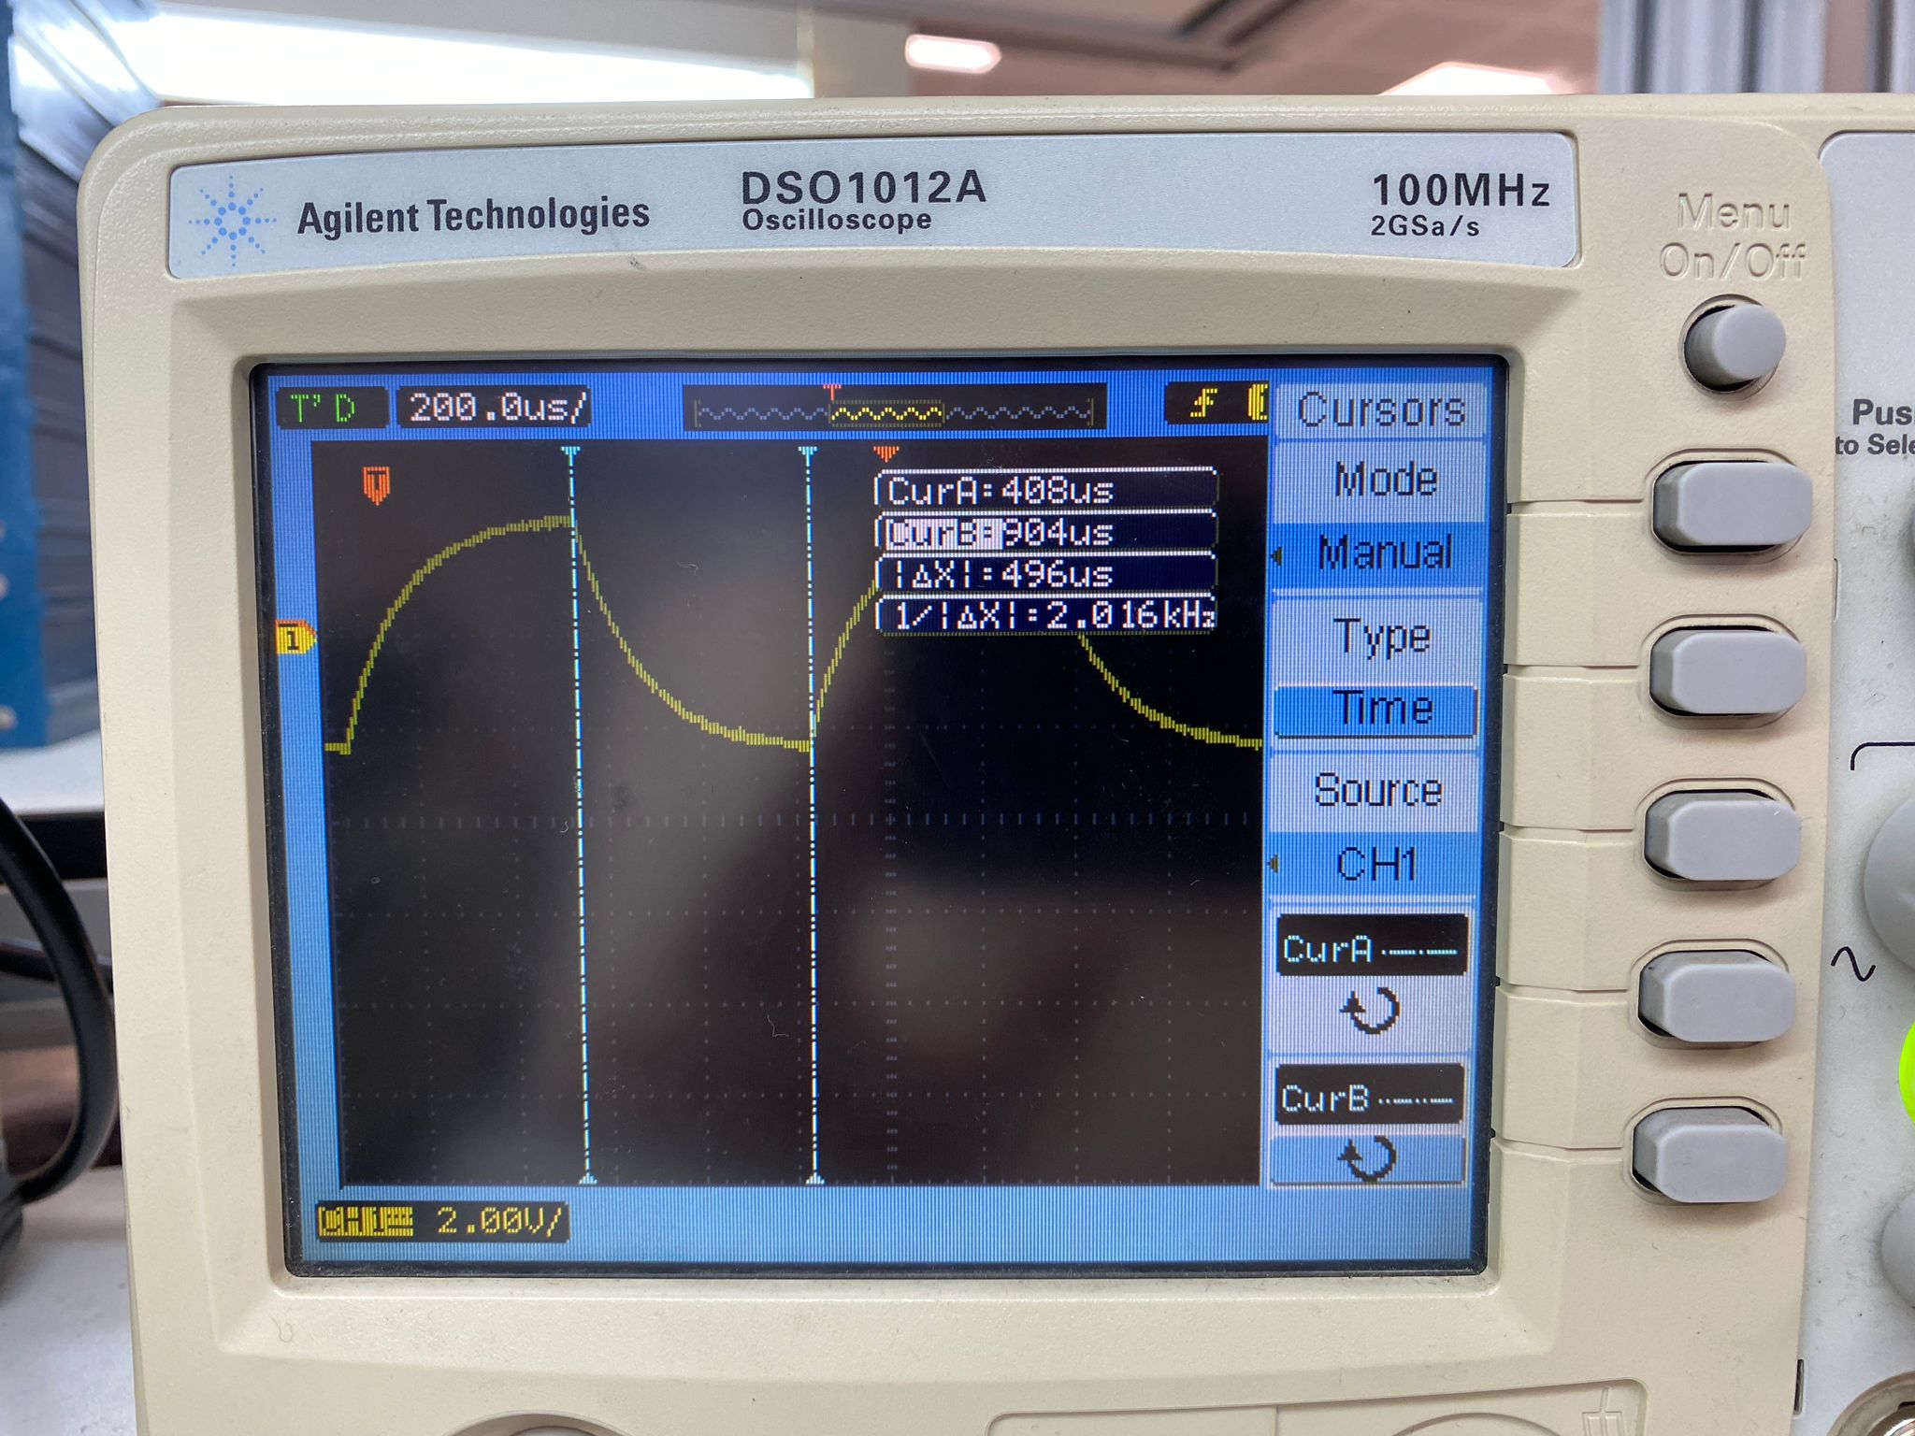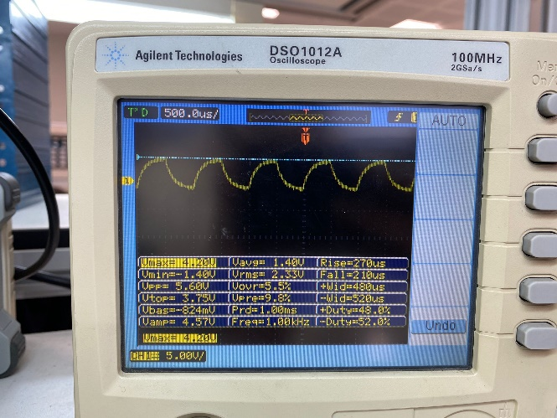
Time Constant 5.6 k Circuit Output

5.6k Time Constant : 1232*10(-7)
3.3k Time Constant : 726*10(-7)
5.6k Rise Time=270us Fall time= 210us
3.3k Rise Time=170us Fall Time=150us

Q4)
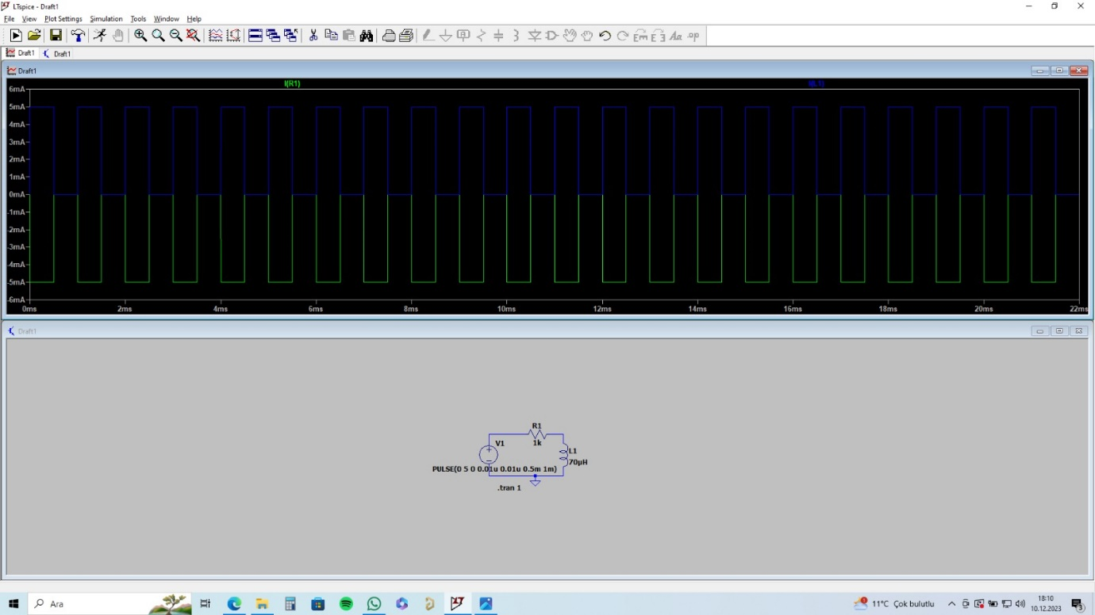

Q5) Time constant explanation is τ=L/R ;
τ= (70 µH) / (1Ω) = 10 µs
Current explanation is i=V/R ;
i = (5V)/(1Ω)=5A

i(t)=i (1-e^((-5τ/τ) ) )

i(t)=5A(1-e^((-5τ/τ) ) ) = 4.96631A

Q6)


